Prelude

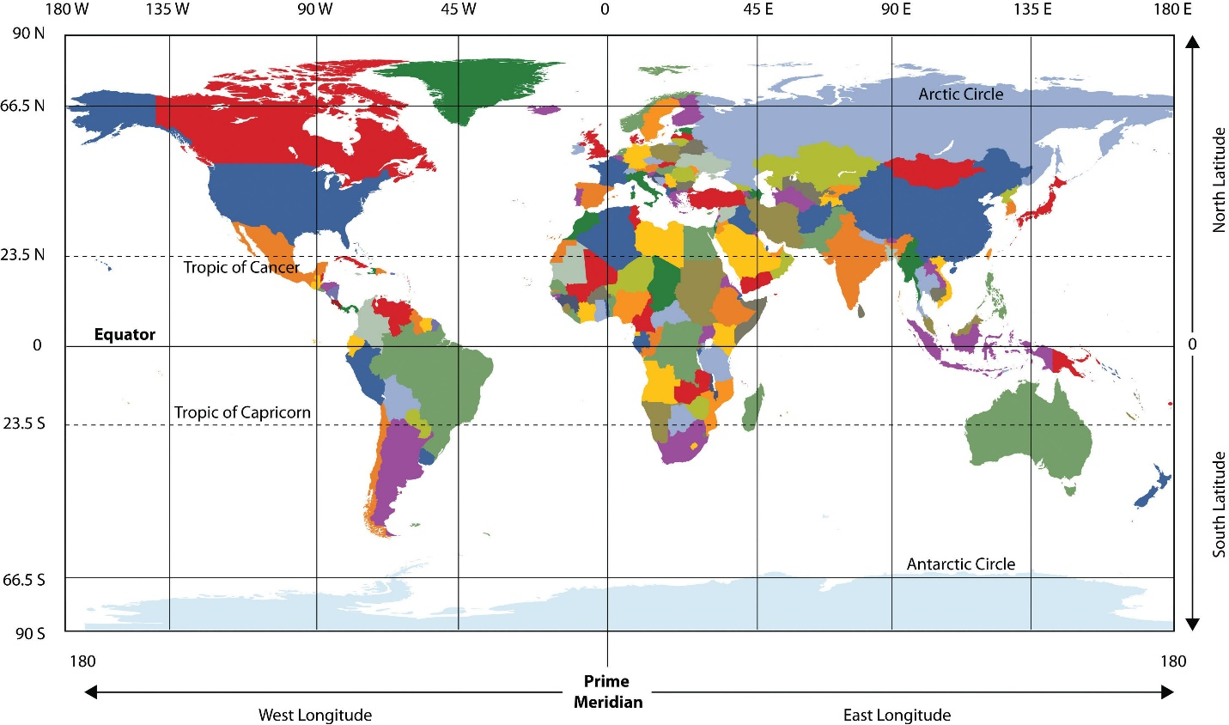

Figure#1:<https://line.17qq.com/articles/fifpjidhz_p2.html>

There are some items to note before we dive into our analysis, all of which ties into latitude.

The first thing to note is we have artic and Antarctic zones that are between 66.5° and 90° N&S (<https://courses.botany.wisc.edu/botany_422/Lecture/pdf/Climate1.pdf>). Here we have a number of factors that comes into play such as:

* Prolonged lengths of days and nights (6 months each).
* Lack of vegetation.

All of these factors show characteristics in varying weather patterns.

The second fact to note is the globe rotates around the sun on a tilt. This means that in early months, northern hemisphere will show higher temperatures than southern hemisphere and in later months, the southern hemisphere will see higher temperatures (summer) while the northern hemisphere will have colder temperatures (winter).

Lastly, it is important to note that there is significantly more land mass in the northern hemisphere than the southern hemisphere. This leads to a higher population, which in turn means there are more datapoints to accurately capture weather items such as temperature, humidity, cloudiness and windspeed.

To take into account the items listed above as well as promote easier visualization of weather trends, the scatter plot graphs on this site will demonstrate weather trends as the move from south (left) to the north( right side) as shown below.

**South**

**North**

**South**

**North**

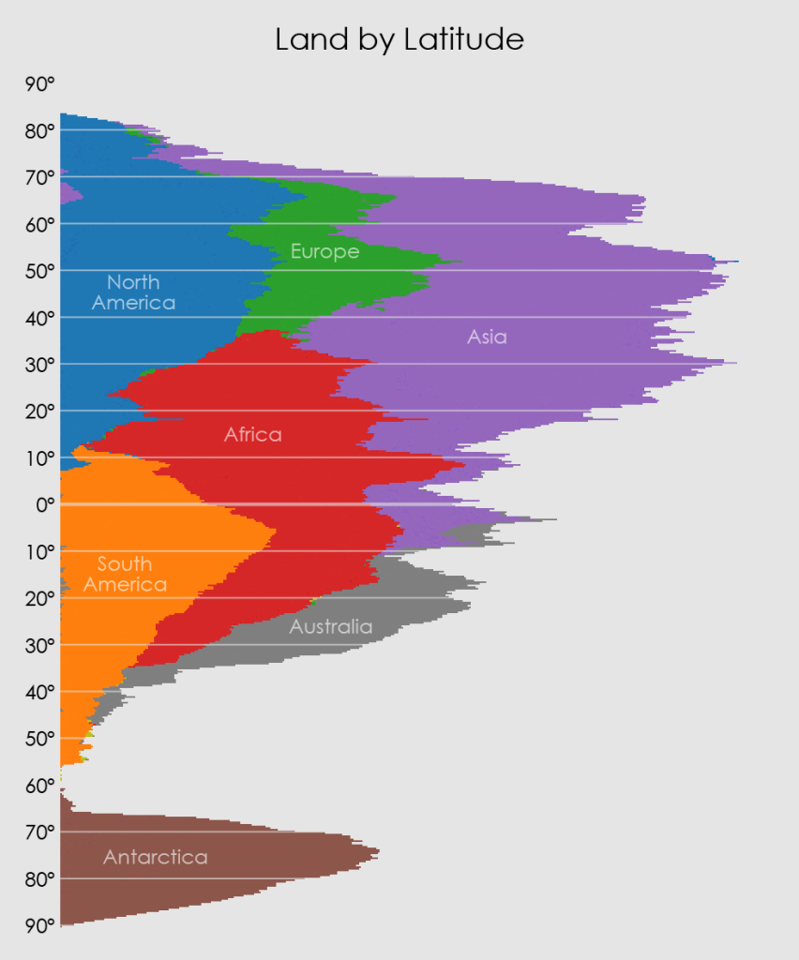

Figure 2: <http://www.ecoclimax.com/2016/08/land-mass-at-each-longitude-and-latitude.html>

Cloudiness

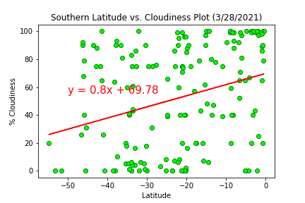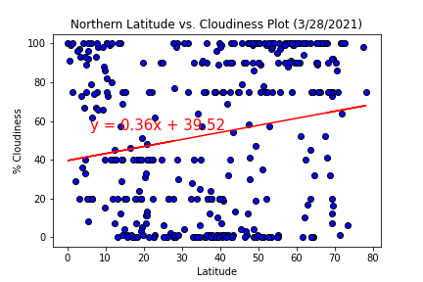

When analyzing the cloud coverage between both the northern and southern latitudes, it is difficult to correlate any trend statistically which is confirmed when applying a linear regression model. One thing to note, is that a pocket of zero cloud coverage can be commonly found at 23.5 N & S. This can be attributed to convection trend cells located from 0° - 23.5°N, 23.5°N -90°N and the same latitudinal coordinates for the southern hemisphere. The same can be assumed for the southern hemisphere however as we reach 90°S, there is a significant decrease in landmass and therefore ability to gather datapoints.

Humidity

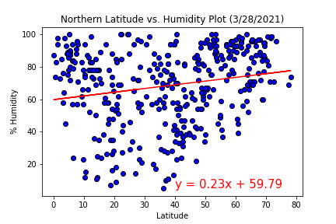

When comparing the humidity plots of the northern and southern hemisphere, we are not able to reach a conclusion based on humidity vs latitude. This is confirmed with the linear regression model shown above. One thing to note is the significantly large number of data points in the northern hemisphere. This is attributed to the larger available land mass as described in the prelude section.

Temperature

When looking at temperature and correlating it to latitude, we find that generally, there are lower temperatures as we approach 90° N & S. This explains the frigid temperatures of the North and South poles and their epic glaciers. In addition to this characteristic of the globe, we can see the gradual temperature increase as we approach the equator at 0°C. This does fit the linear regression and demonstrates a global trend that is independent of elevation.

Wind Speed

When looking at windspeed per latitude, we can see that there are records of higher wind rates in the northern hemisphere. This is attributed to the higher landmass that is associated with increased population and datapoints. This also explains the difference in the windspeed scale for the graphs shown. While, the scatter plot seems to follow a trend that could fit a linear regression model, it still does not provide a high level of accuracy or trend. Further analysis of windspeed and elevation can shed light on more concrete, global trends.

comparisons

More to come

Note that this is just the beginning. As you can see, this analysis of the weather only takes into consideration the weather conditions per latitudinal coordinate. Future work will diver further into how to better corelate weather conditions and location by incorporating elevation and population development pockets into our analysis. We will always strive to bring you the best in weather information so that you can plan your vacations accordingly.